**DETECTION OF POTATO EARLY BLIGHT AND LATE BLIGHT DISEASES USING CONVOLUTIONAL NEURAL NETWORKS AND DEEP LEARNING TECHNIQUES**

**TEAM MEMBERS:**

**2103A52008 - Chilumula Harshavardhan**

**2103A52002 - Alabaka Saivishnu**

**2103A52008 - Bamar Harshavardhan**

**1.ABSTRACT**

Potato (Solanum tuberosum) is one of the world's most essential staple crops, serving as a vital source of nutrition and livelihood for millions of people. However, potato cultivation faces significant challenges due to the prevalence of devastating diseases, such as early blight (Alternaria solani) and late blight (Phytophthora infestans). The timely and accurate detection of these diseases is critical for effective disease management and the preservation of potato yields. Traditional methods of disease diagnosis rely heavily on visual inspection by experts, which can be subjective, time-consuming, and error-prone.

In recent years, the application of advanced machine learning techniques, particularly Convolutional Neural Networks (CNNs) and deep learning, has emerged as a promising avenue for automating disease detection in various crops. This research paper explores the development and implementation of a CNN-based deep learning model for the accurate and efficient identification of potato early blight and late blight diseases. Using PlantVillage dataset from kaggel , we got 100% accuracy on the traning data and 80-100% accuracy on testing data , this model also depicts confidence levels of the disease accuracy and we are planning to expand our community to every crop and plant disease detection.

**2. INTRODUCTION**

The potato is a globally significant crop, providing sustenance to billions of people and contributing significantly to food security. However, the agricultural productivity of potato crops is continually threatened by the occurrence of various diseases, among which early blight (Alternaria solani) and late blight (Phytophthora infestans) stand out as particularly destructive pathogens. These diseases can cause substantial yield losses, adversely impacting both smallholder farmers and large-scale agricultural operations.

Early blight is characterized by the development of small, dark lesions on the leaves of potato plants, while late blight presents as water-soaked, rapidly spreading lesions that can affect not only the foliage but also the tubers themselves. Detecting these diseases early in their development is crucial to implement effective disease management strategies, which can include targeted chemical treatments, optimized irrigation, and timely removal of infected plant material.

Traditionally, the identification of early blight and late blight diseases has relied heavily on human expertise, involving visual inspections of the plants. However, this approach is subject to human error, can be time-consuming, and may not always be feasible, especially in regions with a scarcity of skilled agricultural professionals.

In recent years, the advent of deep learning techniques, particularly Convolutional Neural Networks (CNNs), has revolutionized the field of computer vision, offering the potential for automated and accurate disease detection in crops. CNNs excel at image recognition tasks, making them well-suited for the classification of plant diseases based on visual symptoms. By leveraging these advancements, this research paper proposes a novel approach to detect and distinguish between potato early blight and late blight using CNN and deep learning techniques . [1,4,5]

**2.LITERATURE SURVEY (table -1)**

|  |  |  |  |  |  |  |  |
| --- | --- | --- | --- | --- | --- | --- | --- |
| S.N O | PAPER TITLE | PARAMETERS | MODELS USED | MERITS | DEMERITS/LIMITATI ON AND DRAWBACKS | FUTURE SCOPE | DATASE T USED |
| 1 | Comparative Assessment of Deep Learning to Detect the Leaf Diseases of Potato based on Data Augmentation | The result of MobileNet (98.44%) SBCNN (97.63%) | CNN , ANN , | 1. SBCNN and MobileNet were the best models selected.  2. MobileNet was deployed on smartphones for its efficiency.  3. Data augmentation proved crucial for improving CNN model performance in the study. | 1.Paper offers model overviews, lacking hyperparameters and layer details.  2. Absence of justifications for design choices in the paper. | 1.Suggests investigating model sensitivity to hyperparameters.  2. Focus on variables like learning rates, dropout rates, and layer configurations.  3. Aim is to optimize model performance through parameter tuning. | Three categories of potato diseases such as Potato Early blight, Potato late Blight and Potato Healthy images are sued in this investigation |
| 2 | Detection of Potato Disease Using Image Segmentation and Machine Learning | The Random Forest classifier gives an accuracy of 97% | BPNN,  ANN,  (RF), | 1. This paper proposes an image processing and machine learning-based automatic system . | 2. Limited sample size and potential biases in data collection. | 3. planning to add more plant species in our system for leaf disease detection in the future. | The dataset is collected from publicly available plant village database, which contains more than fifty thousand images of 14 different crop species. Three sample images of potato leaf are shown in We have analyzed 450 images of potato leaves, |
| 3 | Potato Leaf Diseases Detection Using Deep Learning | classification accuracy obtaining 97.8% over the test dataset. | Image segmentation + backpropagation neural network, Image segmentation + Support Vector Machine,  VGG19 ,  Logistic regression | 1. Model employs transfer learning with pre-trained VGG19.  2.Multiple classifiers used, with logistic regression excelling  .  3.Logistic regression achieves 97.8% classification accuracy on the test data. | 4.limited models used , the proposed accuracy may not be continuous for all the areas and various soils | 1. Implement disease detection on smartphones for farmer convenience.  2. Capture leaf images and send to a server for analysis.  3. Server classifies disease and sends results, including medication recommendations, to the smartphone. | In this model 2152 images of potato leaves were taken from a plant village dataset which comprises 1000 images of early blight,1000 images of late blight, and 152 of healthy images of potato leaves. Dataset is divided into two parts: the training part comprises 1700 images(70%) and the test part contains 452 images(30%). |
| 4 | Health Detection for Potato Leaf with Convolutional Neural Network | Machine  Learning | CNN,  Picture Normalization, Color Conversion, VGG16, VGG19, ReLU | 1. Architecture well-suited for plant disease classification.  2. Utilizes a database of over 2,000 images efficiently.  3. Achieves a remarkable 99% accuracy in disease identification. | 1. One potential disadvantage could be the limited models used for data analysis. | 1. Health status of potato leaves detected using CNN architecture.  2. Flexibility to explore alternative models for detection. | 1. under the image database of more than 2,000images |
| 5 | Plant Leaf Diseases Detection and Classification Using Image Processing and Deep Learning Techniques | . Achieved results above 98% using CNN. | CNN,  VGG models,  (ANN) | 1. Achieved results above 98% using CNN.  2. Utilized a substantial dataset for robust data analysis. | 1. Importance of abundant high-quality data for accurate analysis.  2. Risk of overfitting, where model excels on training data but struggles with new data. | 1. Anticipate better data collection with advancing technology.  2. Expect enhanced analysis through improved machine learning techniques. | This Data Set contains 20636 images of plants and their diseases |
| 6 | Comparision of Performance of Classifiers - SVM, RF and ANN in Potato Blight Disease Detection using Leaf Images | Classifier performance comparison: ANN (92%), SVM (84%), RF (79%). | Supportvectormachine (svm)  ,  Random forest(rf),  ANN , FCM clustering | 1. Classifier performance comparison: ANN (92%), SVM (84%), RF (79%).  2. ANN leads in accuracy, followed by SVM and RF on potato leaf data. | 1. Accuracy measured with true positive and false positive values can have limitations.  2. May not perform optimally in certain disease detection scenarios. | 1. Avenue for future exploration could be to expand the study to different plants and leaves | The dataset used here for testing and performance analysis of the proposed system consists of 500 images taken randomly from the database which consists of defected leaf images and normal leaf images. |
| 7 | Potato Leaf Disease Classification Using Deep Learning Approach | This experiment has achieved an average accuracy of 91% | svm | 1. VGG16 and VGG19 show promise for leaf disease image classification.  2. Incorporating data augmentation enhances system robustness. | 1. Limited scope, specific crops, and regions.  2. Uncertainty in climatic models.  3. Lack of comprehensive analysis for late blight and early blight. | 1. They believe this work can bring many benefits in agriculture-related to world food security. | Different image resolutions and sizes were obtained from several sources, |
| 8 | Application of transfer Learning to Detect Potato disease from leaf | The program predicts with an accuracy of 99.43% in testing with 20% test data and 80% train data. | Transfer Learning, CNN, Deep Learning ,CNN ,  VGG19, | 1. Explores late blight and early blight with limited data.  2. Achieves favorable results through transfer learning.  3. Contributes to knowledge for future potato production interventions. | 1. The research paper contains excessive data of 14 crop species which can decrease the performance | 1. Ongoing exploration of diverse plant and leaf effectiveness.  2. Potential future scope for expanding to other plant species. | :. Within the plant village data set of 54,206 images containing 38 classes of 14 crop species and 26 diseases |
| 9 | Plant Leaf Detection and Disease Recognition using Deep Learning | The trained model has achieved an accuracy rate of 96.5% | . plant disease recognition, deep learning, computer vision, convolutional neural network , ANN ,  Relu . | . 1. Paper successfully detects 32 plant varieties and diseases with CNN.  2. Trained model applicable for real-time disease recognition in images. | 1. Limited scope of diseased leaves as the data is mainly focused on the healthy leaves rather than diseased leaves | 1. Future work involves expanding dataset with more plant varieties.  2. Plan to incorporate additional types of plant diseases for model improvement. | Comprised of 35,000 images of healthy plant leaves and infected with the diseases, the researchers were able to train deep learning models to detect and recognize plant diseases and the absence these of diseases. |
| 10 | A Comparative Study of CNN and AlexNet for Detection of Disease in Potato and Mango leaf. | The results show that accuracy achieved from AlexNet is higher than CNN architecture. | Image classification, Deep Learning, Convolutional Neural Network Architecture, AlexNet Architecture | 1. Comparative study: CNN vs. AlexNet for potato and mango leaf disease classification.  2. AlexNet demonstrates higher precision and recall compared to CNN.  3. High precision indicates accurate positive predictions, and high recall signifies accurate positive identification. | AlexNet architecture requires a long time to train, | 1. Explore stress-resistant cultivars for aerobic rice.  2. Optimize nutrient management techniques.  3. Investigate integrated weed control methods.  4. Aim to boost adoption of aerobic rice cultivation. | The potato images were collected from plantvillage The images in the dataset are grouped in 4 classes to differentiate between the healthy and diseased class. There are 2 classes that represent diseased leaves and other 2 classes represent healthy leaves |
| 11 | Utility of Hyperspectral Data for Potato Late Blight Disease Detection | The optimal hyperspectral wavebands to discriminate the healthy plants from disease infested plants were 540, 610, 620, 700, 710, 730, 780 and 1040 nm whereas upto 25% infestation could be discriminated using reflectance at 710, 720 and 750 nm. | Potato crop . Late blight . Reflectance . Spectroradimeter. Vegetation indices . Discriminant analysis | 1. Research focuses on distinguishing healthy and infected potato crops.  2. Utilizes spectral difference analysis with hyperspectral data.  3. Applies stepwise discriminant analysis across the infestation spectrum. | 1. Possible biases or limitations in training and validation data.  2. Study may not address real-world implementation challenges. | 1. Future scope: Enhance crop disease prediction with advanced ML techniques.  2. Expand study to diverse agricultural regions for wider relevance. | Spectral reflectance for potato crop for detection of disease infestation was collected using a 512-channel spectroradiometer (FieldspecPro 2000) with a range of 325 to 1075 nm.. |
| 12 | Potato Disease Detection Using Machine Learning | The proposed CNN model gains 99% accuracy | Potato Disease, Image processing, Machine Learning, Disease Detection, Agriculture ,  CNN. | The proposed CNN model gains 99% accuracy for a particular field which is a good model. | 1.Limited Generalizability:  2. The research focuses on a single model CNN training which may not be accurate always , limited amount of dataset is used | 1. Future scope: Develop an Android app for farmers in Bangladesh.  2. Enable instant disease detection and advice services via the app. | The research paper utilized the collection of total 2034 potato and potato leaves images. |
| 13 | Application of Transfer Learning to Detect Potato Disease from leaf image | technique got 99.43% accuracy | Potato Disease Prediction, Transfer Learning, CNN, Deep Learning | The proposed Transfer learning technique got 99.43% accuracy | 1. Limited evaluation of real-world potential demerit of this research paper is the lack of adequate data | Future research could investigate the inclusion of variables like other plants | The dataset used in this research paper is a publicly available dataset from the website plantvillge.psu |
| 14 | Detection of Potato Diseases Using Image Segmentation and Multiclass Support Vector Machine | Machine learning | SVM, Disease detection, Plant Phenotyping. | 1. The research paper's merit lies in its innovative use of machine learning and phenotyping  2. Another merit of this research paper is the model can work absolutely good for a small field of plants | 1. One potential demerit of this research paper is the reliance on only 300 images of data  2. Another demerit could be usage of single SVM model | 1. The future scope of this research paper lies in further refining the machine-learning framework by giving additional datasets the models performance can be increased | Plant Village (www.plantvillage.org), a publicly available image database, contains 54,306 images of diseased and healthy plant leaves of 14 crop specie climate models. |
| 15 | Leaf Disease Detection using Support Vector Machine | Machine learning  accuracy of just 86% In SVM and 67% in Logistic Regression and 70% in RF | Feature extraction; Image processing; Segmentation; Random Forest; Support Vector Machine (SVM)) (BPNN). | 1. Comprehensive integration of multiple data sources: By incorporating various data sources such from the web may increase the model training performance | 1. Limited consideration low accuracy of just 86% In SVM and 67% in Logistic Regression and 70% in RF | 1. Further exploration of additional data sources: In future research, it would be valuable to consider incorporating more diverse data sources to enhance the accuracy | In this paper, 60 features from each image of 8 different types of classes of tomato leaf are stored in CSV format. Firstly, various types of tomato diseased leaf images are acquired from some from web. |
| 16 | Leaf Disease Detection and Recommendation of Pesticides using Convolution Neural Network | Our results show that the highest accuracy achieved for 5-layer model with 95.05% | NN, Tensor flow, Leaf Disease, ANN. | 1. ML and DL integration improves detection and pesticide recommendations.  2. System combines Android app with Java Web Services and Deep Learning. | One potential demerit of this research paper could be the limited scope of the pesticides availability | 1. Future research potential: Integrate advanced ML and AI for meteorological service improvement.  2. Focus on enhancing extreme weather prediction in smart cities. | The dataset used in this research paper consists huge amount of data from publicly available  data |
| 17 | CNN based Disease Detection Approach on Potato Leaves | This provided model established 97% of great precision. | legitimate sequential model  , Image Processing, Neural Network ,  CNN | 1. The classification algorithm called legitimate sequential model can differentatie between an healthy and unhealthy leaf accurately | 1. The research paper could benefit from providing more detailed explanations of the limitations and potential challenges associated with implementation of the proposed model | 1. Implement a system for leaf health prediction.  2. Blend software and hardware for improved real-time results. | the image data is collected from Kaggle consisting of 3000 images |
| 18 | POTATO LEAF DISEASE DETECTION USING INCEPTION V3 | Deep Learning Attains a 90% accuracy on the test dataset for disease classification | Convolutional neural network, Deep Learning, InceptionV3 | 11. Research employs CNN with Inception V3 and Adam Optimizer.  2. Successfully classifies potato plant diseases (early and late blight). | The pretrained model can work beyond this capacity but the high training errors lead to low accuracy . | The findings of this research paper can be further explored and applied in the field of artificial intelligence. | The dataset that is used in this paper is Plant Village Dataset [1] that is taken from Kaggle |
| 19 | Plant Leaf Diseases Detection and Classification Using Image Processing and Deep Learning Techniques. | Machine Learning. have got an accuracy of (98.29%) for training, and (98.029%) for testing for all data set that were used. | CNN  ANN | 1. Research employs CNN with Inception V3 and Adam Optimizer.  2. Successfully classifies potato plant diseases (early and late blight).  3. Attains a 90% accuracy on the test dataset for disease classification. | One potential limitation can be usage of data . | Various learning rates and optimizers could too be applied as part of future work to experiment with the proposed system. | The dataset was taken from a global data set which is (Plant Village) |
| 20 | Disease Detection of Plant Leaf using Image Processing and CNN with Preventive Measures | Machine Learning. proposed approach where it achieves the overall 97% and 96.1 % accuracy of ResNet-50 and the overall 96.5% and 95.3% accuracy of AlexNet | Image Processing, CNN, AlexNet, ResNet-50, | 1. Paper proposes diagnostic method for tomato and potato leaf diseases.  2. Utilizes image processing and CNN for classification.  3. Classifies diseases using AlexNet and ResNet-50.  4. Provides graphical preventive measures layout for disease control. | 1.The proposed deep-learning approach may require a significant amount of computational resources during the training phase.  2. Another potential disadvantage is that the effectiveness of the proposed approach may heavily rely on the availability and quality of the training data. | 1. The future scope for this research paper lies in exploring the potential of applying the proposed deep-learning approach to other plants  . | The leaf images of tomato and potato are taken from Kaggle dataset.. |

**3. SUMMARY**

**1*.Comparative Assessment of Deep Learning to Detect the Leaf Diseases of Potato based on Data Augmentation***

A study utilized CNN to classify potato leaves, comparing models based on training and validation accuracy/loss. SBCNN and Mobile Net were identified as optimal models, with Mobile Net chosen for smartphone deployment. Data augmentation enhanced CNN performance, countering overfitting from imbalanced datasets. Further CNN architectures could improve the model. Results, including SBCNN's 96.98% validation accuracy (non-augmented) and 96.75% (augmented) with 99.71% and 98.75% training accuracy, were detailed. SBCNN excelled with augmented data, showing no overfitting, and Mobile Net’s performance was evaluated for smartphone integration.

# 2. ***Detection of Potato Disease Using Image Segmentation and Machine Learning***

— Potato is globally vital, gaining popularity in Bangladesh. Diseases, notably Early Blight (EB) and Late Blight (LB), impair growth, especially in leaves. Identifying these diseases early is crucial for optimal production. This study suggests an ML-based image processing system for disease detection, utilizing 450 images from a public database. Image segmentation and seven classifiers are employed. Notably, the Random Forest classifier achieves 97% accuracy, offering an automated solution for plant disease detection, benefiting crop yield.

3*.* ***Potato Leaf Diseases Detection Using Deep Learning***Potato quality and quantity suffer from diseases like early blight and late blight. Manual diagnosis is time-consuming and expertise-dependent. Automated early detection is crucial for better potato production. This paper introduces a model utilizing pre-trained VGG19 for feature extraction through transfer learning. Multiple classifiers were employed, with logistic regression standing out with 97.8% accuracy, improving disease classification efficacy.

4**. *Health Detection for Potato Leaf with Convolutional Neural Network***Potato, a global staple, faces fungal infections causing early and late blight diseases. Timely disease control enhances production and reduces losses. Automating disease identification for farmers is pivotal. This study proposes a CNN architecture for potato disease detection. A training database is created through CNN image processing. Adam optimizer and cross-entropy analysis are employed, with softmax as the final judgment function. The model prioritizes accuracy while minimizing resource utilization, with 10,089,219 parameters. Experimental results validate the proposed model's effectiveness, achieving 99% disease judgment accuracy.

5. ***Plant Leaf Diseases Detection and Classification Using Image Processing and Deep Learning Techniques***

Agricultural stability hinges on disease-free plants. This paper introduces a deep learning-based system for classifying and detecting plant leaf diseases. Images sourced from the Plant Village dataset were used, focusing on tomatoes, peppers, and potatoes due to their global prevalence, particularly in Iraq. The dataset comprises 20,636 images of plants and their diseases. Utilizing a convolutional neural network (CNN), the proposed system classifies 15 categories, including 12 disease types (bacteria, fungi, etc.) and 3 healthy leaf categories. Impressively, the system achieved remarkable accuracy: 98.29% during training and 98.029% during testing across the entire dataset.

# 6**. *Comparision of Performance of Classifiers - SVM, RF and ANN in Potato Blight Disease Detection using Leaf Images***

This research emphasizes efficient disease management in agriculture, crucial for optimal yield and loss reduction. Automated tools are invaluable for farmers. The study focuses on potato cultivation, a major global food crop. Fungal infections, such as early blight and late blight, adversely affect potato crops. These manifest as brown spots and lesions on leaves. The paper proposes automated disease detection using image processing and machine learning. Classifiers, including Support Vector Machine (SVM), Random Forest (RF), and Artificial Neural Network (ANN), are evaluated on a potato leaf test dataset. ANN exhibits the best performance, achieving a high accuracy of 92%.

7. ***Potato Leaf Disease Classification Using Deep Learning Approach***

Potato, a vital staple globally and increasingly in demand due to the pandemic, faces disease-related quality and quantity decline. Timely disease classification is crucial to prevent worsening plant conditions. This study introduces a system using deep learning (VGG16 and VGG19) to classify four potato diseases based on leaf conditions. With an average accuracy of 91%, the experiment validates the efficacy of deep neural networks. VGG networks prove promising for effective leaf disease image classification. Incorporating data augmentation enhances system robustness. The proposed method's success, averaging 91% accuracy, is anticipated to positively impact agriculture and global food security.

8. ***Application of Transfer Learning to Detect Potato Disease from Leaf Image***

Potato, a vital global crop, faces diseases impacting production and farmer livelihoods. Early automatic disease detection can boost production and digitize farming. This paper aims to detect potato diseases using advanced machine learning. Transfer learning is highlighted for early disease detection with limited leaf images. It utilizes pre-trained deep learning models for new problems. The experiment includes 152 healthy leaves, 1000 Late blight leaves, and 1000 early blight leaves. Achieving a 99.43% accuracy on a 20% test dataset, transfer learning outperforms other models, demonstrating its potential for superior potato disease detection..

9**. *Plant Leaf Detection and Disease Recognition using Deep Learning***

Recent advancements in deep learning and computer vision have enabled the use of cameras to detect and diagnose plant diseases by analyzing images. This study offers an efficient solution for identifying various diseases across different plant types, including apples, corn, grapes, potatoes, sugarcane, and tomatoes. With a dataset containing 35,000 images of healthy and diseased leaves, deep learning models were trained to achieve a 96.5% accuracy rate in disease detection and plant recognition. The system's accuracy reached 100% in identifying plant varieties and disease types. Agriculture is a crucial sector globally, and timely disease recognition is essential. The paper successfully employs convolutional neural networks (CNNs) to detect and identify 32 plant varieties and diseases, with potential for real-time applications. Future work involves expanding the dataset, exploring different CNN architectures, and optimizing performance. With its 96.5% accuracy, the proposed model can aid farmers in disease detection and recognition.

10.***A Comparative Study of CNN and AlexNet for Detection of Disease in Potato and Mango leaf***

Deep Learning (DL), a rapidly growing subset of machine learning, employs Convolutional Neural Networks (CNN) for highly accurate image classification. CNNs offer various pre-trained architectures like AlexNet, GoogleNet, ResNet, etc. In this study, CNN and AlexNet are applied to detect diseases in Mango and Potato leaves, with a focus on accuracy and efficiency comparison. A dataset of 4004 images is utilized, sourced from Plant Village and GBPUAT locations. Results reveal AlexNet's superior accuracy over CNN. The paper conducts a comparative analysis of disease classification on both leaves using the two architectures. AlexNet exhibits higher precision and recall, signifying accurate predictions. Although training time is longer due to more layers, AlexNet yields better results in distinguishing diseased from healthy leaves. Future work aims to develop a mobile app for quick disease detection, aiding farmers in effective crop management. Additionally, this research underscores DL's capability to distinguish significant image features.

11**. *Utility of Hyperspectral Data for Potato Late Blight Disease Detection.***

The study was carried out at village Nijjarpura (31° 34’29” and 75°01’00”) in district Amritsar of Punjab state in IndiaThe study was carried out to investigate the utility of hyperspectral reflectance data for potato late blight disease detection. The hyperspectral data was collected for potato crop at different level of disease infestation using hand-held spectroradiometer over the spectral range of 325–1075 nm. For hyperspectral analysis of infestation of late blight of potato, 10 spectral profiles from each severity of infestation were taken and then averaged. These reflectance profiles contained spectral wavelengths from 325 to 1075 nm with 1 nm interval and the spectral data were averaged over 10 nm to reduce the number of data set to 75 bandwidths. The average spectral profiles were plotted and compared. Differences of spectral reflectance between healthy and diseased plants were also compared, quantitatively, at different regions of VNIR (visible and near infrared) wavelengths. Correlation was computed between spectral reflectance at different bands and diseases intensity. The effect of disease on reflectance was also studied using first order derivative curves. The step wise discriminant analysis and spectral method are used to test the infected crop , The analysis was done both for the whole range of infestation level and also from disease free to only 25% infestation

12. ***Potato Disease Detection Using Machine Learning***

Potato is a vital crop in Bangladesh, but its production faces hindrance from diseases that escalate farmers' costs and disrupt their lives. Automated disease detection can enhance potato production and modernize the agricultural system. This study employs advanced machine learning to diagnose potato diseases using leaf images. Through image processing and machine learning, an automated system for identifying and classifying potato leaf diseases is proposed. Over 2034 images of unhealthy and healthy potato leaves from a publicly available plant database are processed. Several pre-trained models are employed for disease recognition and classification, achieving an impressive 99.23% accuracy on a test dataset split into 25% testing and 75% training data. This research surpasses existing methods in potato disease detection, primarily focusing on using machine learning, specifically Convolutional Neural Networks (CNN). The achieved 99% validation accuracy showcases the model's effectiveness, aiming to revolutionize the agriculture sector in Bangladesh. To empower illiterate farmers, future plans include creating an Android application capable of detecting and providing solutions for various crop diseases. Increasing the database size is anticipated to further improve accuracy, while building an Android app will enable instant assistance and advice for farmers' disease-related concerns.

13. ***Application of Transfer Learning to Detect Potato Disease from leaf image***

This research paper main objective is to detect the potato diseases with a few leaf image data using advanced machine learning techniques. In this paper, we demonstrate that transfer learning technique could be used for early detection of potato diseases when it is difficult to collect thousands of new leaf images. Transfer learning uses already trained deep learning model’s weight to solve new problem. The experiments included images of 152 healthy leaves, 1000 Late blight leaves, and 1000 early blight leaves. The program predicts with an accuracy of 99.43% in testing with 20% test data and 80% train data. We also compared sequential deep learning model with several pretrained model applying transfer learning and found that transfer learning provided best result till date. Our output showed that transfer learning outperform all existing works on potato disease detection.

14**. *Detection of Potato Diseases Using Image Segmentation and Multiclass Support Vector Machine***

The research paper introduces a machine-learning framework that includes Modern phenotyping and plant disease detection provide promising step towards food security and sustainable agriculture. In particular, imaging and computer vision based phenotyping offers the ability to study quantitative plant physiology. On the contrary, manual interpretation requires tremendous amount of work, expertise in plant diseases, and also requires excessive processing time. In this work, we present an approach that integrates image processing and machine learning to allow diagnosing diseases from leaf images. This automated method classifies diseases (or absence thereof) on potato plants from a publicly available plant image database called ‘Plant Village’. Our segmentation approach and utilization of support vector machine demonstrate disease classification over 300 images with an accuracy of 95%. Thus, the proposed approach presents a path toward automated plant diseases diagnosis on a massive scale

15. ***Leaf Disease Detection using Support Vector Machine***

This research paper focuses on To identify and monitor the leaf diseases manually by farmers is very difficult. This is one of the reasons to develop an automatic leaf diseases detection model. The proposed model helps in automatic detection of different plant diseases at early stages. Thus, the production will increase in many folds. The main aim of this study is to identify different types of leaf diseases. Different feature extraction techniques have been used to enhance the classification accuracy. Support Vector Machine (SVM), Random Forest and Logistic Regression have been applied to classify different types of leaf diseases. When obtained results are compared SVM outperforms other two classifiers. Results show that, the model can be used in real life applications.

16. ***Leaf Disease Detection and Recommendation of Pesticides using Convolution Neural Network***

In this paper they proposed the system which works on preprocessing, feature extraction of leaf images from plant village dataset followed by convolution neural network for classification of disease and recommending Pesticides using Tensor flow technology. The main two processes that we use in our system is android application with Java Web Services and Deep Learning. We have use Convolution Neural Network with different layers five, four & three to train our model and android application as a user interface with JWS for interaction between these systems. Our results show that the highest accuracy achieved for 5-layer model with 95.05% for 15 epochs and highest validation accuracy achieved is for 5- layer model with 89.67% for 20 epochs using tensor flow

17. ***CNN based Disease Detection Approach on Potato Leaves***

In this research paper, the authors discusses about how the potato leaf disease causes significant damage to the potatoes.. Various types of diseases such as early blight, late blight, septoria blight etc. will attack potato plants and exhibit their syndrome in the leaf of these disorders. The farmer would not face incurring major economic losses if these outbreaks are detected at the primary stage and sufficient action is taken. The proposed model will strongly identify and detect diseases of potato leaf stand on image processing methods in this research paper. Machine Learning includes several algorithms, but the CNN model is used for this research to detect the disease from images of the potato leaf because in CNN is used for image classification & it gives the best result than others. There are 5 algorithms is used for this research they are AlexNet, VggNet, ResNet, LeNet & Sequential model which is our offered one. Normal & disorder-impacted leaf were used for the model provided in order to segregate normal and abnormal aspects of potato leaf. Those kind of photographs are then analyzed through the algorithm provide & the potato plant leaf is labeled as either diseased or normal. This provided model established 97% of great precision.

18. ***POTATO LEAF DISEASE DETECTION USING INCEPTION V3***

- Agriculture is one of the major sectors in our society and from the medieval times, it is the sector that we have dwelled upon. About 60-70% of Indian population depends on the agricultural industry. Across the world, loss faced by the crop due to numerous factors like weeds, diseases and arthropods have increased to an alarming rate of about 34.9% in 1965 to about 42.1% in the late 1990s. Potato plants face various infections due to bacteria and fungi. Fungal diseases infecting plants are early blight and late blight. Our paper presents a CNN model and an algorithm to detect such diseases through the leaf of the crop. The model that we have created is trained to analyze and understand a diseased leaf and thereafter recognize the disease of the leaf. We are using InceptionV3 algorithm.

19**. *Plant Leaf Diseases Detection and Classification Using Image Processing and Deep Learning Techniques***

This paper presents a system that is used to classify and detect plant leaf diseases using deep learning techniques. The used images were obtained from (Plant Village dataset) website. In our work, we have taken specific types of plants; include tomatoes, pepper, and potatoes, as they are the most common types of plants in the world and in Iraq in particular. This Data Set contains 20636 images of plants and their diseases. In our proposed system, we used the convolutional neural network (CNN), through which plant leaf diseases are classified, 15 classes were classified, including 12 classes for diseases of different plants that were detected, such as bacteria, fungi, etc., and 3 classes for healthy leaves. As a result, we obtained excellent accuracy in training and testing, we have got an accuracy of (98.29%) for training, and (98.029%) for testing for all data set that were used.

20.***Disease Detection of Plant Leaf using Image Processing and CNN with Preventive Measures***

This research paper introduces a novel approach to address the plant disease detection , this paper proposes plants leaf disease detection and preventive measures technique in the agricultural field using image processing and two well-known convolutional neural network (CNN) models as AlexNet and ResNet-50. Firstly, this technique is applied on Kaggle datasets of potato and tomato leaves to investigate the symptoms of unhealthy leaf. Then, the feature extraction and classification process are performed in dataset images to detect leaf diseases using AlexNet and ResNet50 models with applying image processing. The experimental results elicit the efficiency of the proposed approach where it achieves the overall 97% and 96.1% accuracy of ResNet50 and the overall 96.5% and 95.3% accuracy of AlexNet for the classification of healthy-unhealthy leaf and leaf diseases, respectively. Finally, a graphical layout is also demonstrated to provide a preventive measures technique for the detected le.

**3.2 PROBLEM STATEMENT**

* Detect potato early blight and late blight diseases using CNN a deep learning algorithm.
* Developing an ai model which can identify whether a potato is healthy or not with more accuracy.
* Importing the data into tensorflow in the model gives wide range of data modification varieties leading to better accuracy , which is not done by many models . We used a model which imported dataset into tensorflow.

**4. METHODOLOGY**

**4.1 ARCHITECTURE:**

Data Cleaning

(Normalization)

Data Preprocessing

(resizing ,augumentation)

PlantVillage dataset

Model Training with cross validation

Model Optimisation

Model Initialization

Evaluation of Accuracy Using CNN model .

**4.2 STEPS:**

1. Dataset Selection
2. Importing the data into tensorflow pipeline
3. Data Preprocessing and Cleaning
4. Visualize some of the datasets.
5. Split the dataset.
6. Cache , shuffle and prefetch the dataset
7. Splitting data into training data and testing data
8. Model Initialization
9. Model Training with Cross Validation
10. Generate data and take new data
11. Model Optimization
12. Apply CNN algorithm on testing data
13. Evaluation of Accuracy

**5. EXPERIMENTAL WORK**

**Set-Up Infrastructure**

* Google colaboratory , VS code , Jupyter
* Import required libraries Matplotlib , Tensorflow , Keras , Numpy , Pandas ..

**Data cleaning**

* Upload the collected dataset.
* Process the data into **tensorflow input pipeline.**
* **Convert the dataset into tensor dataset**
* Clean the null values if present in provided dataset.

**Model Evaluation**

* Creating a Layer for resizing and Normalization
* Data Augmentation
* CNN model with Softmax activation in the output layer
* Compile the model
* We use adam Optimizer, SparseCategoricalCrossentropy for losses, accuracy as a metric

**CNN ARCHITECTURE**:

Output layer with softmax activation

Fully connected layers

Flatten

Pooling

Convolutional + Relu layers

Kernal / leaf images

**5.2 DATASET DESCRIPTION**

**LINK:**  <https://www.kaggle.com/arjuntejaswi/plant-village>

* The dataset consists of PlantVillage

Pepper__bell___Bacterial_spot – 997 files

Pepper__bell___healthy – 1478 files

* Potato___Early_blight – 1000 files

* Potato___Late_blight – 1000 files

* Potato___healthy - 152 files

Tomato_Bacterial_spot – 2127 files

Tomato_Early_blight – 1000 files

Tomato_Late_blight – 1909 files

Tomato_Leaf_Mold – 952 files

Tomato_Septoria_leaf_spot – 1771 files

Tomato_Spider_mites_Two_spotted_spider_mite – 1676 files

Tomato__Target_Spot – 1404 files

Tomato__Tomato_YellowLeaf__Curl_Virus – 3209 files

Tomato__Tomato_mosaic_virus – 373 files

Tomato_healthy – 1591 files

**Importing of data set images :**

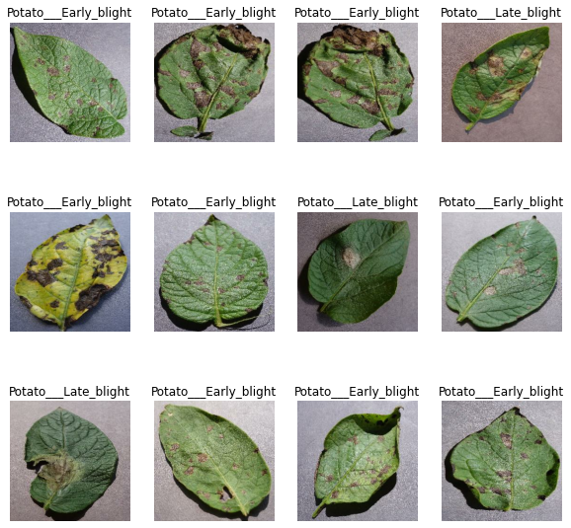

Fig1 – data visualization

**6. RESULTS**

### **6.1 Plotting the Accuracy and Loss Curves**

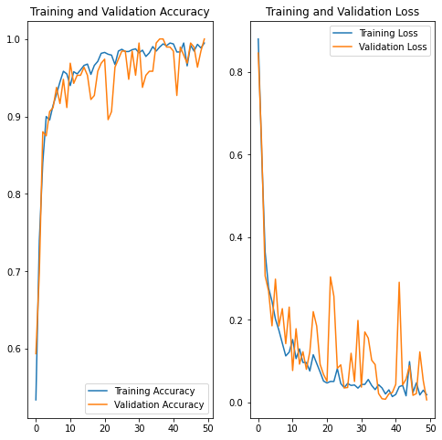

Fig 2 : Accuracy curve and loss curve

**6.2 Accuracy:**

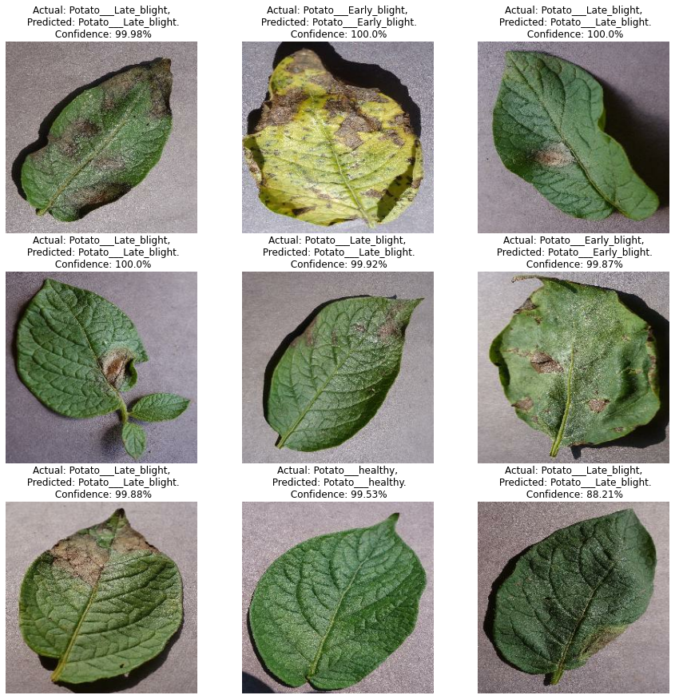

Fig 3: Accuracy on testing data with confidence percentage

**6.3 MODEL ACCURACY SCORES:**

By using CNN model we can tell wether the potato is late blight or early blight with certain percentage of confidence . This confidence% indicates the accuracy of the model

### **6.4 Run prediction on a sample image :**

first image to predict

actual label: Potato___Early_blight

predicted label: Potato___Early_blight

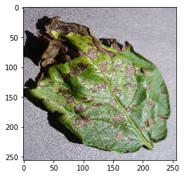

Fig 4 : Testing accuracy on a single image

**7. CONCLUSION AND FUTURE SCOPE**

To predict the infected potato leaf from the collected dataset, we have used CNN model which demonstrated a very good confidence levels while predicting weather the potato leaf is healthy or if it is infected by late blight or early blight. **we get 100.00% accuracy for our test dataset. This is considered to be a pretty good accuracy.** The performance of the model, heavily depends on the dataset and quality of the images. If the image was taken in the good amount of light the model can easily detect the infected and healthy leaves with best confidence percentage. If the image was taken in the dim light the models confidence level drops. The analysis does not address other models like SVM Random forest and ALEXNET which also shows good accuracy score . We are thinking to develop an sever based applications which detect most of the diseases in the farming plants and also suggests which prevention and cure methods can be applied for it.

**8.REFERENCES**

[1] : Barman, U., Sahu, D., Barman, G. G., & Das, J. (2020, July). Comparative assessment of deep learning to detect the leaf diseases of potato based on data augmentation. In *2020 International Conference on Computational Performance Evaluation (ComPE)* (pp. 682-687). IEEE.

[2] : Iqbal, M. A., & Talukder, K. H. (2020, August). Detection of potato disease using image segmentation and machine learning. In *2020 international conference on wireless communications signal processing and networking (WiSPNET)* (pp. 43-47). IEEE.

[3] : Tiwari, D., Ashish, M., Gangwar, N., Sharma, A., Patel, S., & Bhardwaj, S. (2020, May). Potato leaf diseases detection using deep learning. In *2020 4th international conference on intelligent computing and control systems (ICICCS)* (pp. 461-466). IEEE.

[4] : Lee, T. Y., Yu, J. Y., Chang, Y. C., & Yang, J. M. (2020, February). Health detection for potato leaf with convolutional neural network. In *2020 Indo–Taiwan 2nd International Conference on Computing, Analytics and Networks (Indo-Taiwan ICAN)* (pp. 289-293). IEEE.

[5] : Jasim, M. A., & Al-Tuwaijari, J. M. (2020, April). Plant leaf diseases detection and classification using image processing and deep learning techniques. In *2020 International Conference on Computer Science and Software Engineering (CSASE)* (pp. 259-265). IEEE.

[6] : Patil, P., Yaligar, N., & Meena, S. M. (2017, December). Comparision of performance of classifiers-svm, rf and ann in potato blight disease detection using leaf images. In *2017 IEEE international conference on computational intelligence and computing research (ICCIC)* (pp. 1-5). IEEE.

[7] : Sholihati, R. A., Sulistijono, I. A., Risnumawan, A., & Kusumawati, E. (2020, September). Potato leaf disease classification using deep learning approach. In *2020 international electronics symposium (IES)* (pp. 392-397). IEEE.

[9] : Militante, S. V., Gerardo, B. D., & Dionisio, N. V. (2019, October). Plant leaf detection and disease recognition using deep learning. In *2019 IEEE Eurasia conference on IOT, communication and engineering (ECICE)* (pp. 579-582). IEEE.

[12] : Tarik, M. I., Akter, S., Al Mamun, A., & Sattar, A. (2021, February). Potato disease detection using machine learning. In *2021 Third International Conference on Intelligent Communication Technologies and Virtual Mobile Networks (ICICV)* (pp. 800-803). IEEE.

[13] : Kosamkar, P. K., Kulkarni, V. Y., Mantri, K., Rudrawar, S., Salmpuria, S., & Gadekar, N. (2018, August). Leaf disease detection and recommendation of pesticides using convolution neural network. In *2018 fourth international conference on computing communication control and automation (ICCUBEA)* (pp. 1-4). IEEE.

[16] : Kosamkar, P. K., Kulkarni, V. Y., Mantri, K., Rudrawar, S., Salmpuria, S., & Gadekar, N. (2018, August). Leaf disease detection and recommendation of pesticides using convolution neural network. In *2018 fourth international conference on computing communication control and automation (ICCUBEA)* (pp. 1-4). IEEE.

[17] : Asif, M. K. R., Rahman, M. A., & Hena, M. H. (2020, December). CNN based disease detection approach on potato leaves. In *2020 3rd International Conference on Intelligent Sustainable Systems (ICISS)* (pp. 428-432). IEEE.

[20] : Tirupati Rao, S., Reddy, L., & Dileep, P. (2023). Disease Detection of a Plant Leaf using Image Processing and CNN with Preventive Measures. *Turkish Journal of Computer and Mathematics Education (TURCOMAT)*, *14*(2), 972-979

**USED MODEL FROM : model developed by MR.DHAVAL PATEL SIR from codebasics**

**LINK :** [**https://codebasics.io/**](https://codebasics.io/)

**LINK : https://github.com/codebasics/potato-disease-classification**

**USED DATSET :**[**https://www.kaggle.com/arjuntejaswi/plant-village**](https://www.kaggle.com/arjuntejaswi/plant-village)